**ASSIGNMENT PYTHON – 4**

**Q-1) Write a Program to print new list which contains all the first Characters of strings present in a**

**list.....**

**LIST_STATES = ["GOA","RAJASTHAN","KARNATAKA","GUJRAT","MANIPUR", “MADHYA PRADESH”]**

->

LIST_STATES = ["GOA","RAJASTHAN","KARNATAKA","GUJRAT","MANIPUR","MADHYA PRADESH"]

first_letter=[]

for x in LIST_STATES:

first_letter.append(x[0])

print(first_letter)

**Q-2) Write a program to replace each string with an integer value in a given list of strings.**

**The replacement integer value should be a sum of AScci values of each character of type**

**corresponding string........**

**LIST: ['GAnga', 'Tapti', 'Kaveri', 'Yamuna', 'Narmada' ]**

->

LIST=['GAnga', 'Tapti', 'Kaveri', 'Yamuna', 'Narmada']

Ascii=[]

for x in LIST:

sum=0

for y in x:

sum+=ord(y)

Ascii.append(sum)

print(Ascii)

Output: [446, 514, 610, 619, 692]

**Q-3) You have to run your any Program at 9:00am. Date: 14th April 2020.**

->

import datetime

import time

task_date = datetime.datetime(2020, 4, 14, 9, 0, 0)

while datetime.datetime.now() < task_date:

time.sleep(1)

print("Hello! Its 14th April")

**Q-4) GIve a tuple:**

**tuple = ('a','l','g','o','r','i','t','h','m')**

**1. Using the concept of slicing, print the whole tuple**

**2. delete the element at the 3rd Index, print the tuple.**

->

t= ('a','l','g','o','r','i','t','h','m')

print(t[0:])

t = t[:2] + t[3:]

print(t)

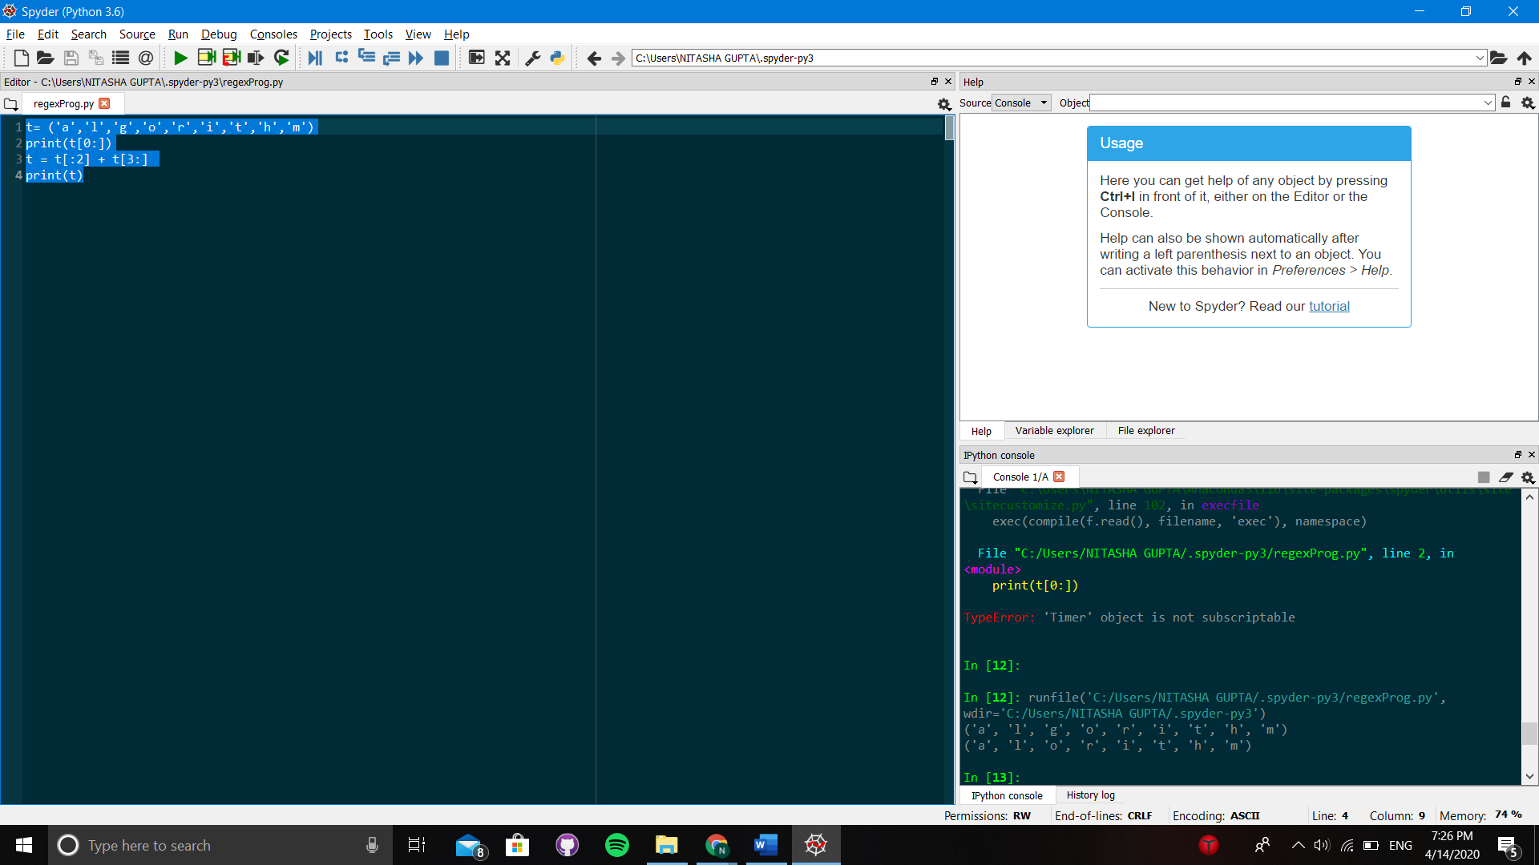

**Q-5) Take a list REGex=[1,2,3,4,5,6,7,8,9,0,77,44,15,33,65,89,12]**

**- print only those numbers greator then 20**

**- then print those numbers those are less then 10 or equal to 10**

**- store these above two list in two different list.**

Sol.

REGex=[1,2,3,4,5,6,7,8,9,0,77,44,15,33,65,89,12]

list1=[]

list2=[]

for i in REGex:

if i > 20:

list1.append(i)

if i <= 10:

list2.append(i)

print(list1)

print(list2)

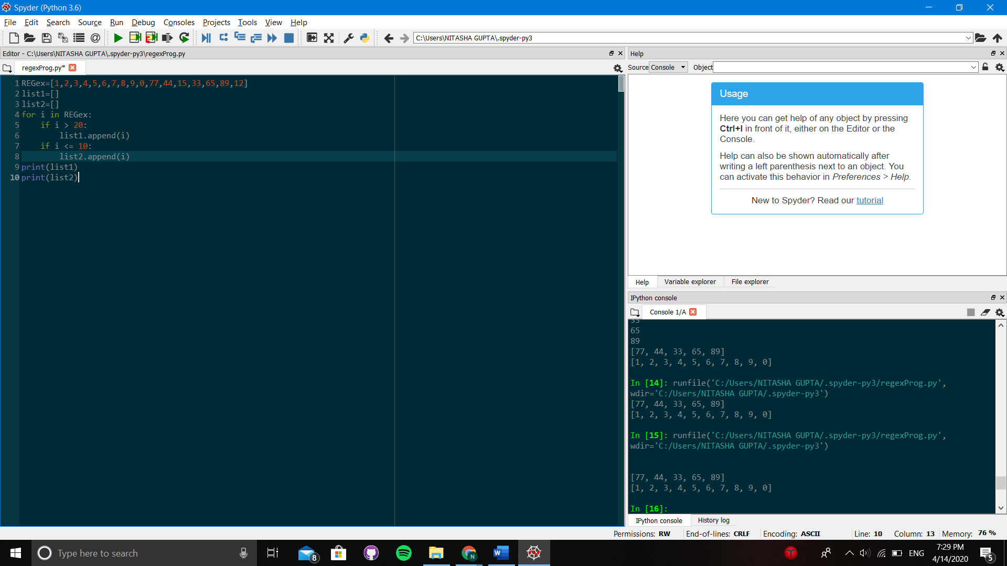

**Q-6) Execute standard LINUX Commands using Python Programming**

Sol.

import os

cmd = 'wc -l my_text_file.txt > out_file.txt'

os.system(cmd)

**Q-7) Revise *args and **kwargs Concepts**

Sol.

def totalSum(*args):

result = 0

for x in args:

result += x

return result

def concStr(**kwargs):

result = ""

for arg in kwargs.values():

result += arg

return result

print(totalSum(1, 2, 3))

print(concStr(a="This", b="is", c="a", d="Python", e="Program"))

